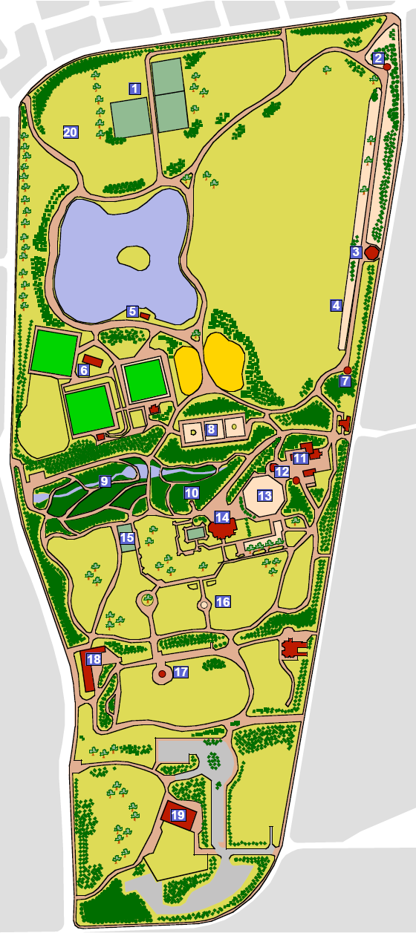
½
POINT A - START

Point Z -
FINISH

Event Control & Registration Area
A
B
C
G
H
J
L
N
T
Y1
?

POINT T -EXIT PARK
R
Q
FINISH
I
M
Y
B
C
A
Y1
X
U
V
Z1
D
E
F
K
O
P
S
W
X

3½ Laps

Finish

Marshal
points

Medical

Radio 
communication

Senior 10 km course,

start – approx 12:30pm

(Sat 17th Dec 2011)

APPENDIX 3b








